ATMEGA In-Depth

In this class we'll cover working with the AT chips using the Arduino environment , but without the Arduino board. We will load bootloaders onto the ATmegas using a programmer board. Once we have done that you can load code onto the chip to test your digital I/O, PWM output and analog input pins. Feel free to use the resistor and photoresistor to build a voltage divider to check your analog input pins with either of the chips once you have established how to load code onto your chip.
Then we'll cover the 8-pin ATTINY85 and programming it from the stand alone AT328 that you build.

The day will look some thing like this;
9-10 introductions, loading software, settling in
10-11 building the first circuit AT328, trouble shooting,
Example code and power mode manipulation
11-12 questions moving to the ATTINY85, loading files for the AT85
Examples with the AT85
12-1 lunch
1-5 Mike on the Internals of the ATMEGA's
Fuse bits (clock source and brown out detection),
AVR dude and Objective Development Crosspack,
Watchdog Timer, and the Datasheet

Materials:
AT328MEGA microController
FTDI Basic USB to serial breakout
16MHz Ceramic Oscillator
Push button
.1uf Capacitor
10K resistor
Jumper wires
3 LEDs
ATTINY85 Microcontroller

Hi!
Welcome to the ATMEGA in-depth class. We hope that this class removes the mystery around working with the ATMEGA 328 chip outside of the Arduino development board.
Arduino is a very powerful tool as you have already figured out. What it lacks, is flexibility in terms of the physical form it takes in a project. You also may have noticed the cost of embedding the whole Arduino board in a project. Using just an ATmega or another chip as the microcontroller for your project costs less, take us less room than a development board and if you know what you are doing, it’s often more versatile than using a development board.

This class assumes a level of comfort within the Arduino environment, so it's a little hardware heavy. That being said, we will explore some “tuning“ in the software. Both the ATMEGA328 and The ATTINY85 have specific tricks to programming and if you are moving around between an Arduino board and these chips you'll need to be very aware of the specific demands within each platform.

What is the Arduino Board?
Power regulation and source
Brownout
Filter capacitors
FTDI
External Clock

Arduino is a bundle of electronic components that put all the necessary pieces to support a microcontroller on one board. Arduino is not the only Company to do this, There are many “Development boards' that do this, BASIC stamp, Beagle, NetDuino, the list is actually quite long.
So what’s on the board? To start with there is power regulation, supplying clean 5volt power to the chip. When we say “clean” we mean no spikes in the voltage that the chip might interpret as an errant signal. There’s a circuit that selects power from the USB and power from an outside source. There is also a brownout circuit to detect a low voltage condition and pull the reset pin low to avoid the programming from performing erratically if the voltage is low. There are a couple capacitors that filter out voltage draw that might otherwise restart the chip. Also on the board is a chip that converts the USB data stream to serial and vice versa so the computer can talk to the chip through the USB port, negating the need for a serial or parallel port.
Then at the chip level itself there is an oscillator providing the 16Mhz signal that clocks the chip. The ATMEGA 328 has an internal oscillator running at 8Mhz. This oscillator is perfectly capable of running the chip, but we will show you how to use a resonator to externally clock the chip.

All of this begs the question “At the most basic level what does the chip need to run?” The simple answer is power. But, in order to begin programming it we need a few more things.

Serial, USB and data transfer
You are hopefully already familiar with the serial terminal from the Arduino environment. Serial refers to one piece of data after another after another sequentially.

USB restructures the data so it can be transferred more quickly. USB also means we have one port for all peripherals: some of you may remember what it was like before USB.
In order to structure the data so the 328 can understand it we'll use an FTDI basic. The FTDI buffers the incoming data and delivers it to the chip in serial form. The FTDI also handles the “handshake” between the chip and the programming environment. The Rx (receive) and Tx (transmit) pins are the pins we're concerned with. Rx on the AT328 connects to Tx on the FTDI and Tx on the AT328 connects to Rx on the FTDI respectively.
The Arduino board features an auto reset and we will incorporate this into our board by connecting the DTR pin on the Basic FTDI to the reset pin. This pulls the reset pin to ground at the beginning of the upload in order to set the chip to an upload ready state.
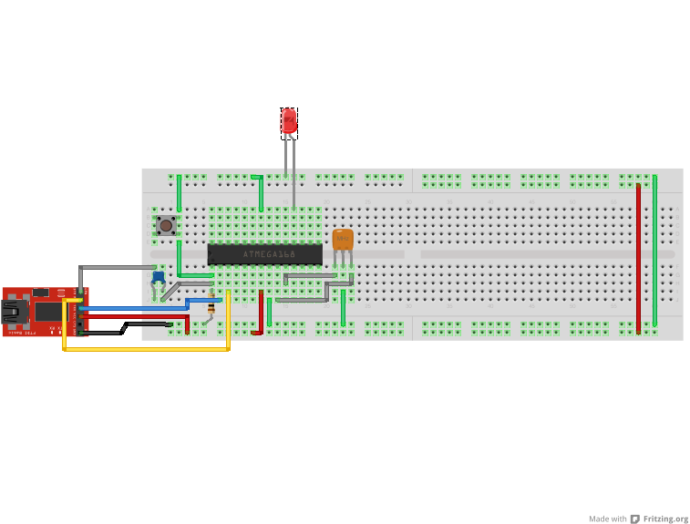
While bread boarding the chip we'll start at pin 1 and move counterclockwise.
Pin1 is connected to 5 volts with a 10k resistor. The 10k resistor holds the reset pin high, keeping the chip from resetting. Pin 1 is also connected to the DTR pin of the FTDI through a 10uf capacitor. This circuit will pull the reset pin low in order to prepare the chip for new code. As well as the DTR reset we will put in a manual reset button by wiring from pin 2 through a momentary button to ground. Pin 18 is the output for the blink sketch, by placing our led between pin 18 and ground we can check to see if our wiring is functional and load some time changes through the Arduino environment to check and see if the programming is working. Pin 22 goes to ground.
Next, wire pin 7 to the 5v positive supply and pin 8 to ground. Pin 9 goes to one side of a ceramic oscillator and pin 10 goes to the other side, the center pin of the oscillator is connected to ground. I have connected an LED from pin 13 to ground for troubleshooting purposes. Using the digitalWrite command in Arduino means we don't need a current limiting resistor. Finally, I connect the avcc pin to a 5v power supply.
The board is pretty well set at this point, but we will need to hook up the FTDI.

The DTR pin connects to the reset button through a .10uF capacitor. Why a capacitor you may ask? The capacitor takes voltage spikes out of the reset circuit to defeat false reset signals, also the discharge curve provided makes the auto-reset feature in Arduino functional, it won’t work without it.

Side Note For Mac:
If your hardware is a combination of an Arduino UNO and a Mac you will need to up the value of the capacitor in this circuit to 10uF instead of .10uF.

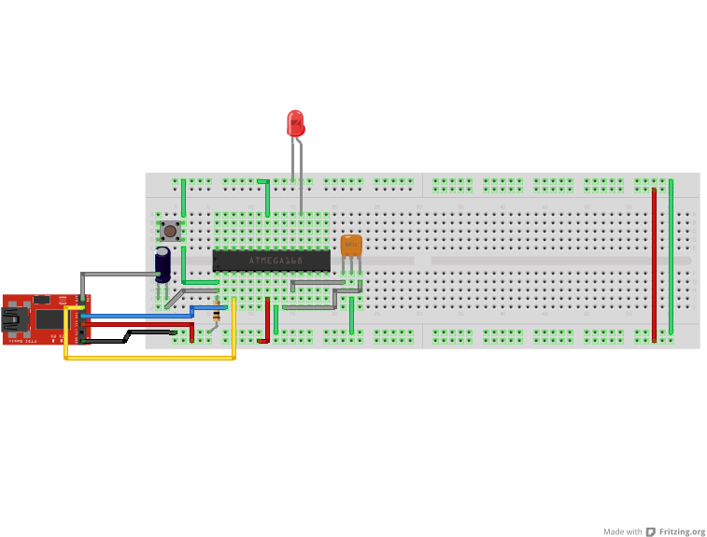

Sorry about that, gotta take care of all the OS’, not just you PC people.

From the RX pin on the FTDI we'll go to pin 3 (Tx) on the chip and from the TX pin on FTDI to the RX pin on the chip, pin 2. I use the 5v supply on the FTDI to power the chip. The ground is the final connection to be made.

In your windows environment
There is an adjustment to make in windows to activate the auto-reset from Arduino. From the control panel, go to ”Printers and other Hardware”. Once inside your “Printers and other Hardware” window click “System” on the left side of the window. This will open your “System Properties” window.
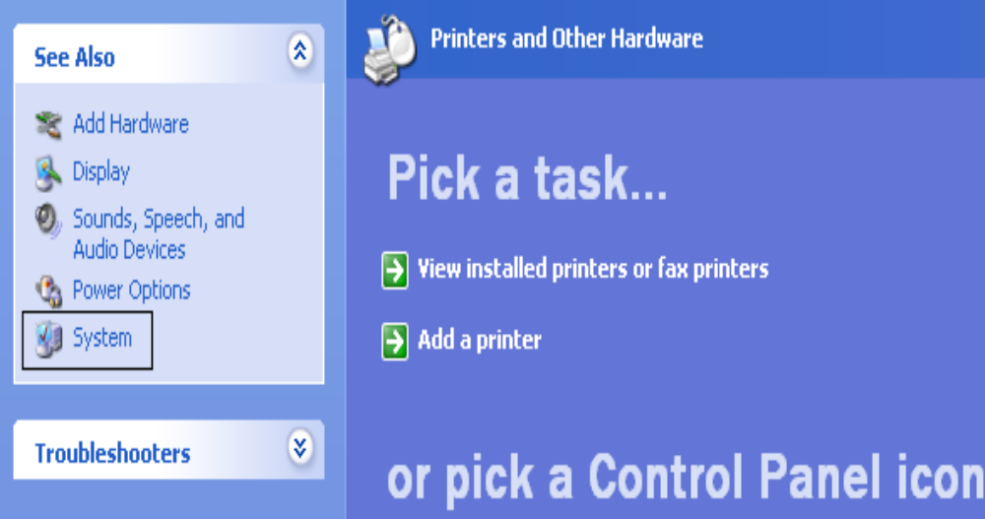
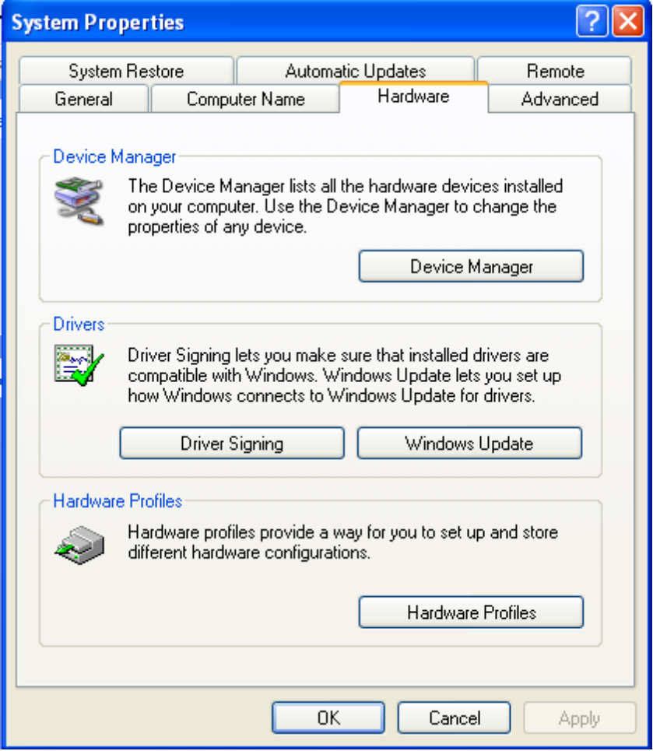
After opening the “System Properties” window select the hardware tab and click on the button labeled “device manager”.

Then, a list of installed or peripheral devices should show up. I look for the
“Ports” menu item and then find which Com port my FTDI is under.
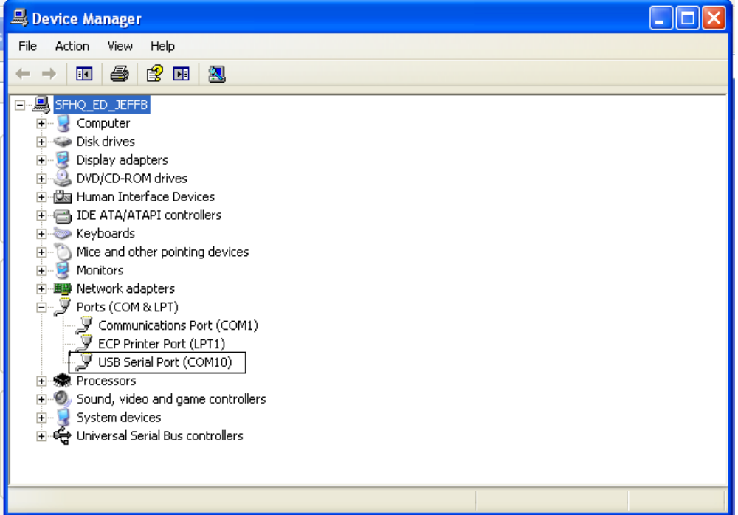

Double click the Port your FTDI is connected to and the Properties window will pop up. Click on “port settings”, from the “port settings” window click “advanced”. If all went well you should see the menu screen for advanced settings for this com port. (shown on next page)

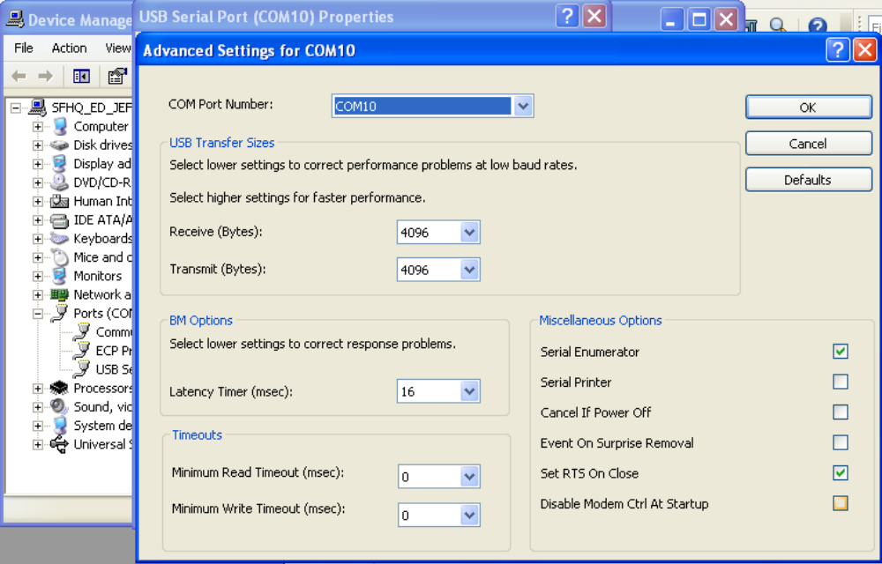

In the lower right hand section there is an option to “set RTS to close”, check this box and hit the “OK” button. You can now close all your COM Port windows.

The First Program
In keeping with tradition, let’s load blink and see if you've got a working setup.
Open Arduino, click on the file tab, look in examples, and basics for the Blink Sketch. If all has gone well you should see this:
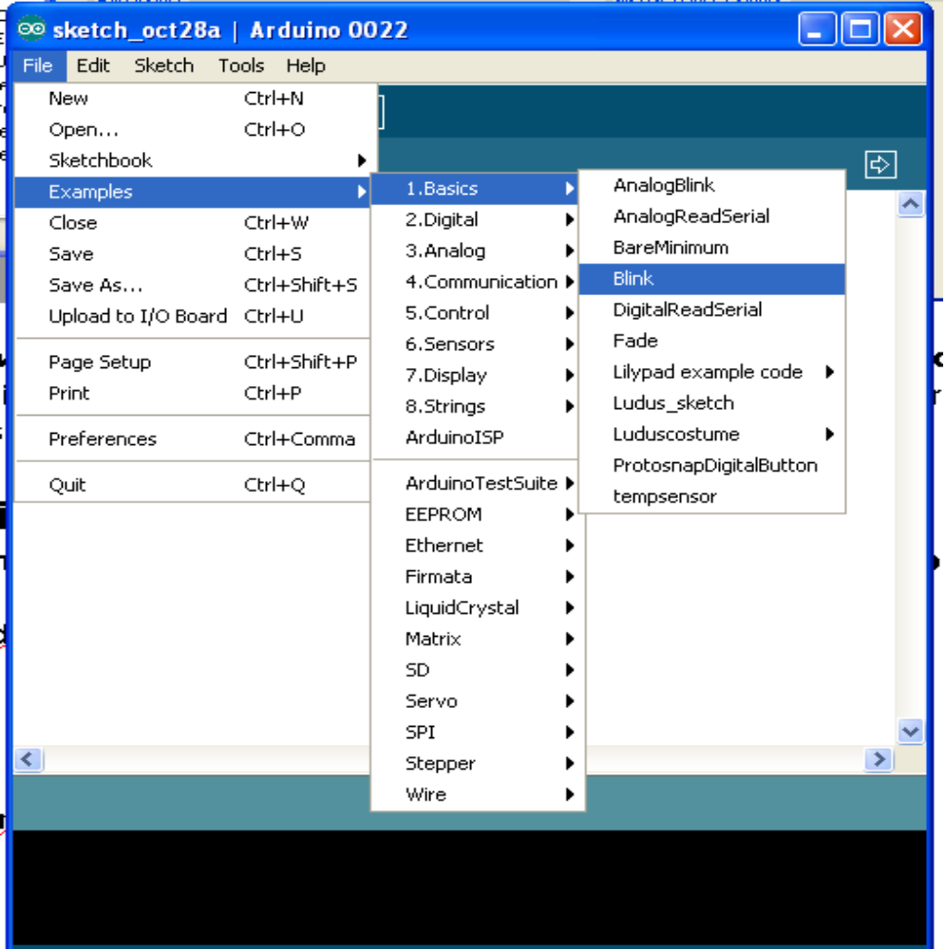
Select Arduino Uno and your Com port from the tools section :
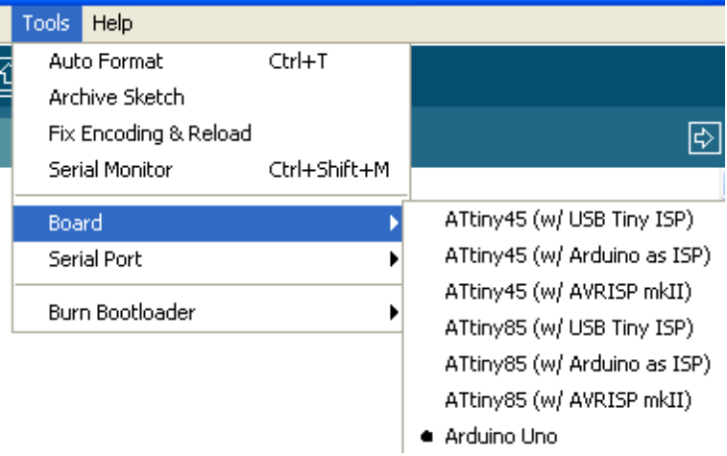

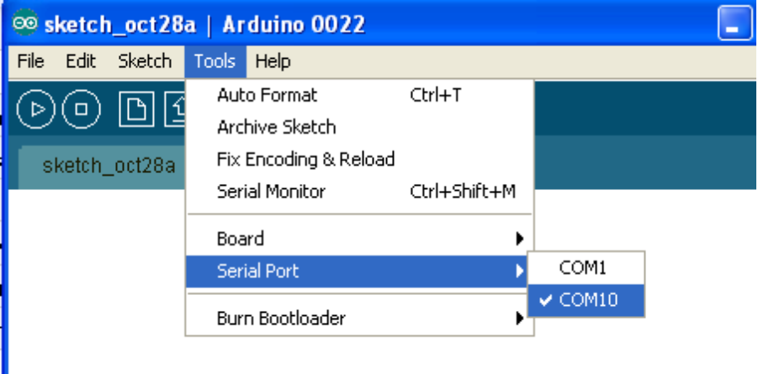
You should now be able to upload the Blink sketch and with any luck your LED will light up!

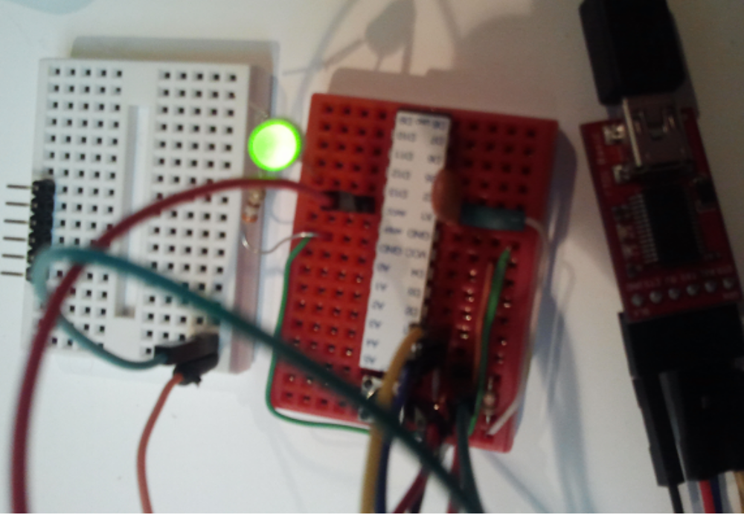
Any number of programming exercises can be run from here, it's all the same as the Arduino Development board, only less expensive.

Arduino as an ISP and the ATTINY85
Thanks to the folks at the MIT media lab, we can use the AT328 as a programmer for the
8-pin ATTiny85 and ATTiny45 chips, all the while using the Arduino environment.
Let’s look at how to do it.
We need to get some libraries and load them into our Arduino environment first. If it's not on your computer yet, go to GitHub and download the code from this page- http://hlt.media.mit.edu/?p=1229 this URL is case sensitive. We also have it on thumb drives.

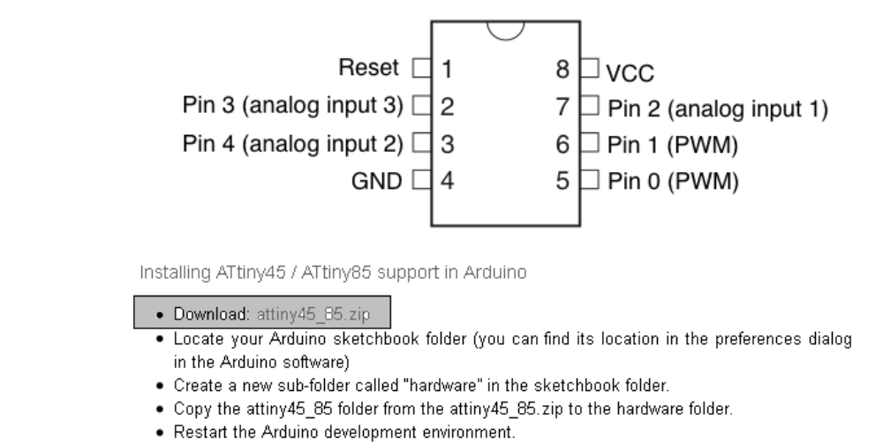

The download will need to be unzipped to the hardware file in Arduino.
Windows will ask were to extract the files to.
For Windows extract the files to the hardware folder and restart the Arduino environment.
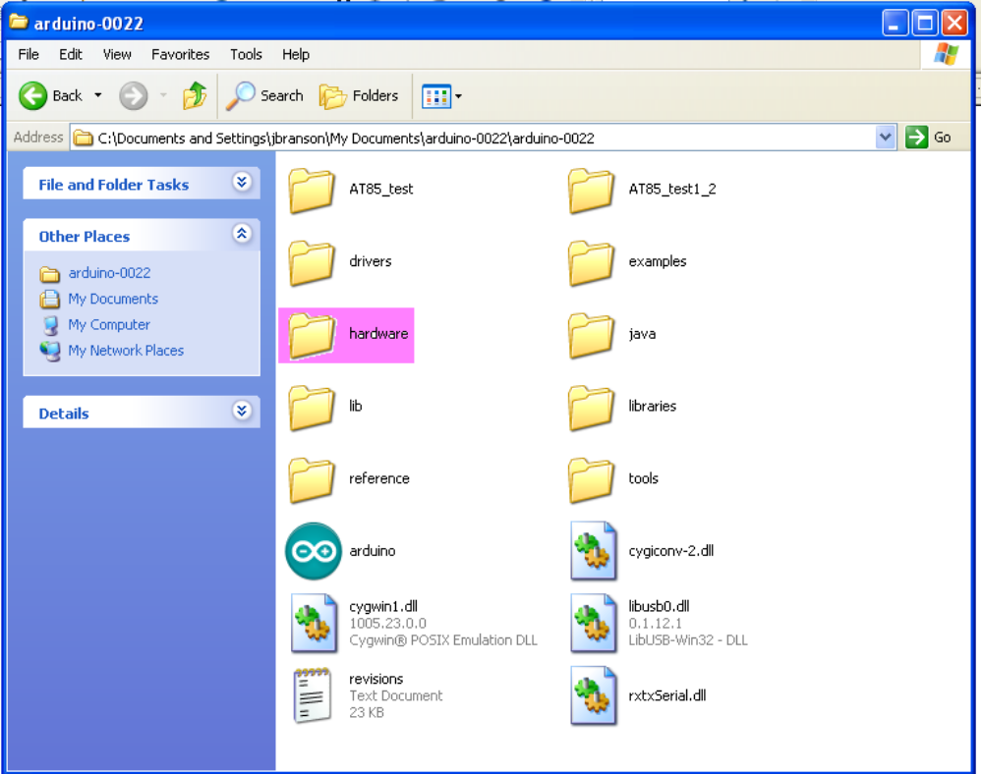

For Mac’s, wow. This is nuts, I can’t actually find the arduino folder I need.

When you restart the Arduino environment, go to the board menu and there should be a host of new boards.

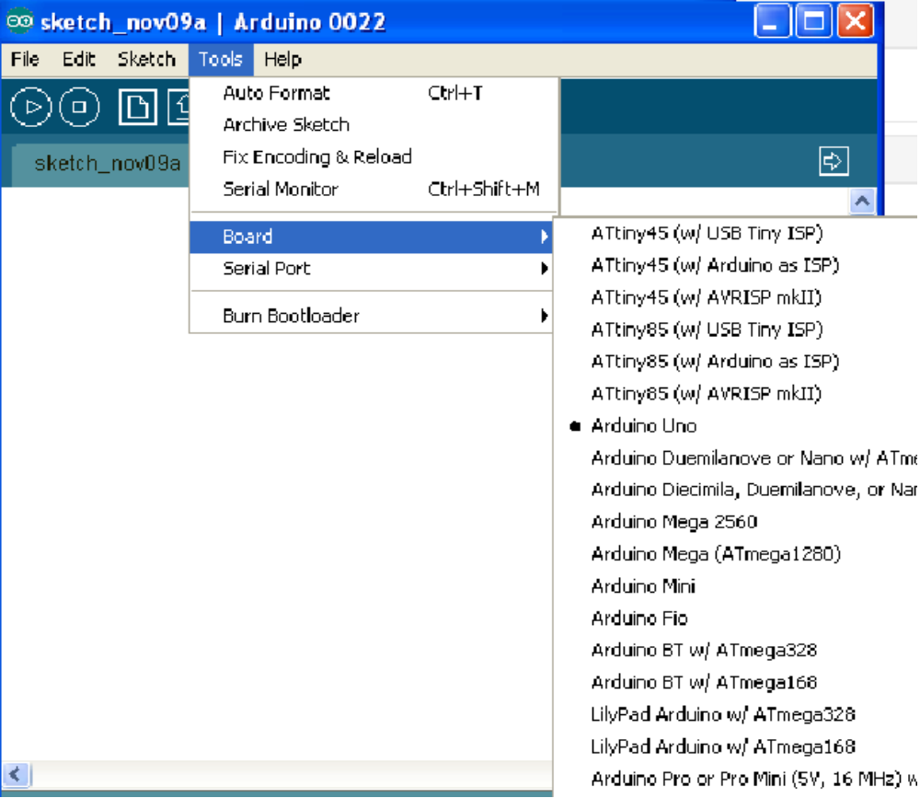

We need to set the 328 as a programmer, so we'll go the examples sketch in Arduino, from there select ArduinoISP. Load this sketch to the 328.

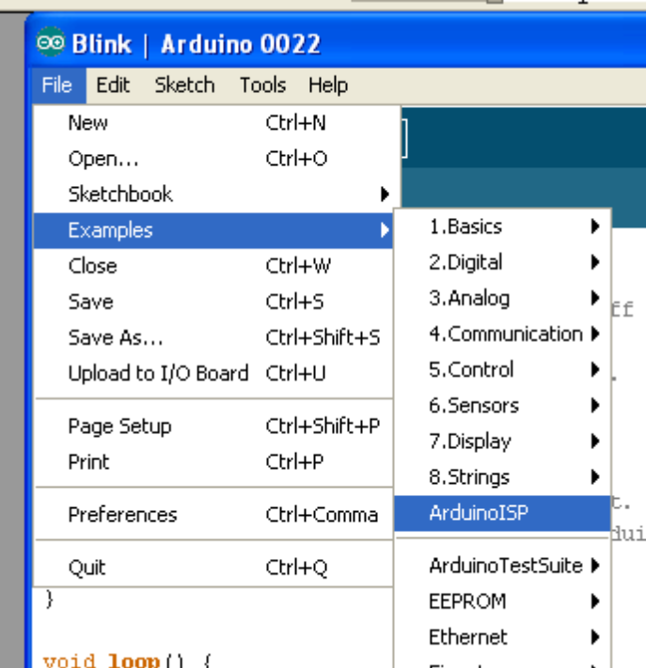

Now lets look at the ATTINY85

The Chip
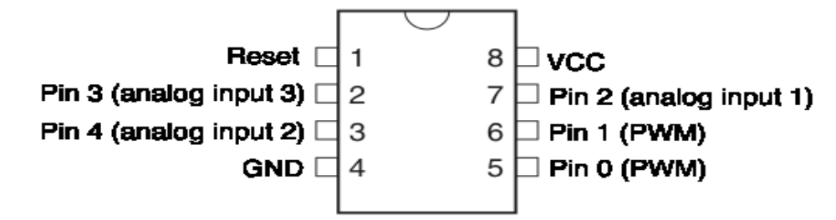

The 85 supports the common commands in Arduino of;

pinMode()
digitalWrite()
Write a HIGH or a LOW value to a digital pin.
If the pin has been configured as an OUTPUT with pinMode(), its voltage will be set to the corresponding value: 5V (or 3.3V on 3.3V boards) for HIGH, 0V (ground) for LOW.
If the pin is configured as an INPUT, writing a HIGH value with digitalWrite() will enable an internal 20K pullup resistor (see the tutorial on digital pins). Writing LOW will disable the pullup. The pullup resistor is enough to light an LED dimly, so if LEDs appear to work, but very dimly, this is a likely cause. The remedy is to set the pin to an output with the pinMode() function.
NOTE: Digital pin 13 is harder to use as a digital input than the other digital pins because it has an LED and resistor attached to it that's soldered to the board on most development boards. If you enable the pin’s internal 20k pull-up resistor, it will hang at around 1.7 V instead of the expected 5V because the onboard LED and series resistor pull the voltage level down, meaning it will return LOW. If you must use pin 13 as a digital input, use an external pull down resistor.

digitalRead()
Reads the value from a specified digital pin, either HIGH or LOW.

analogRead()
Reads the value from the specified analog pin. The Arduino board contains a 6 channel (8 channels on the Mini and Nano, 16 on the Mega), 10-bit analog to digital converter. This means that it will map input voltages between 0 and 5 volts into integer values between 0 and 1023. This yields a resolution between readings of: 5 volts / 1024 units or, .0049 volts (4.9 mV) per unit. The input range and resolution can be changed using analogReference().
It takes about 100 microseconds (0.0001 s) to read an analog input, so the maximum reading rate is about 10,000 times a second.

analogWrite()
Writes an analog value (PWM wave) to a pin. Can be used to light an LED at varying strength or drive a motor at various speeds. After a call to analogWrite(), the pin will generate a steady square wave of the specified duty cycle until the next call to analogWrite() (or a call to digitalRead() or digitalWrite() on the same pin). The frequency of the PWM signal is approximately 490 Hz.
On most Arduino boards (those with the ATmega168 or ATmega328), this function works on pins 3, 5, 6, 9, 10, and 11. On the Arduino Mega, it works on pins 2 through 13. Older Arduino boards with an ATmega8 only support analogWrite() on pins 9, 10, and 11. You do not need to call pinMode() to set the pin as an output before calling analogWrite().
The analogWrite function has nothing whatsoever to do with the analog pins or the analogRead function.

shiftOut()
Shifts out a byte of data one bit at a time. Starts from either the most (i.e. the leftmost) or least (rightmost) significant bit. Each bit is written in turn to a data pin, after which a clock pin is pulsed (taken high, then low) to indicate that the bit is available.
Note: If you're interfacing with a device that's clocked by rising signals, you'll need to make sure that the clock pin is low before the call to shiftOut (), e.g. with a call to digitalWrite (clockPin, LOW).
This is a software implementation; see also the SPI library, which provides a hardware implementation that is faster but works only on specific pins.

pulseIn()
Reads a pulse (either HIGH or LOW) on a pin. For example, if value is HIGH, pulseIn() waits for the pin to go HIGH, starts timing, then waits for the pin to go LOW and stops timing. Returns the length of the pulse in microseconds. Gives up and returns 0 if no pulse starts within a specified time out.
The timing of this function has been determined empirically and will probably show errors in longer pulses. Works on pulses from 10 microseconds to 3 minutes in length.

millis()
Returns the number of milliseconds since the Arduino board began running the current program. This number will overflow (go back to zero), after approximately 50 days.
micros()
Returns the number of microseconds since the Arduino board began running the current program. This number will overflow (go back to zero), after approximately 70 minutes. On 16 MHz Arduino boards (e.g. Duemilanove and Nano), this function has a resolution of four microseconds (i.e. the value returned is always a multiple of four). On 8 MHz Arduino boards (e.g. the LilyPad), this function has a resolution of eight microseconds.
Note: there are 1,000 microseconds in a millisecond and 1,000,000 microseconds in a second.

delay()
Pauses the program for the amount of time (in miliseconds) specified as parameter. (There are 1000 milliseconds in a second.)
delayMicroseconds()
Pauses the program for the amount of time (in microseconds) specified as parameter. There are a thousand microseconds in a millisecond, and a million microseconds in a second.
Currently, when using delayMicroseconds(), the largest value that will produce an accurate delay is 16383. This could change in future Arduino releases. For delays longer than a few thousand microseconds, you should use delay() instead.

SoftwareSerial()
The Arduino hardware has built-in support for serial communication on pins 0 and 1 (which also goes to the computer via the USB connection). The native serial support happens via a piece of hardware (built into the chip) called a UART. This hardware allows the Atmega chip to receive serial communication even while working on other tasks, as long as there room in the 64 byte serial buffer.
The SoftwareSerial library has been developed to allow serial communication on other digital pins of the Arduino, using software to replicate the functionality (hence the name "SoftwareSerial").

Limitations
Because it's not supported by hardware, the library has a few limitations:
- Only speeds up to 9600 baud work
- Serial.available() doesn't work
- Serial.read() will wait until data arrives
- Only data received while Serial.read() is being called will be received. Data received at other times will be lost, since the chip is not "listening".
SoftwareSerial appears to have some timing issues and/or software issues. Check this forum thread for discussion. Software Serial Discussion. In particular, if you are having problems using SoftwareSerial with an Atmega168 chip delete SoftwareSerial.o in your Arduino directory.

Let's wire the 328 to the ATTiny85 as a programmer. The 85 will need power and ground, so run a wire from the power pin on the 328 (Pin7 or the rail) to pin 8 on the 85. After that connect ground to ground, and finally, connect the 328 pin 8 to 85 pin .

Next connect 328 pin 10 to 85 pin 1, the reset circuit.
Connect from 328 pin 11 to 85 pin 5, 328 pin 12 to 85 pin 6 and 328 pin 13 to 85 pin 7.

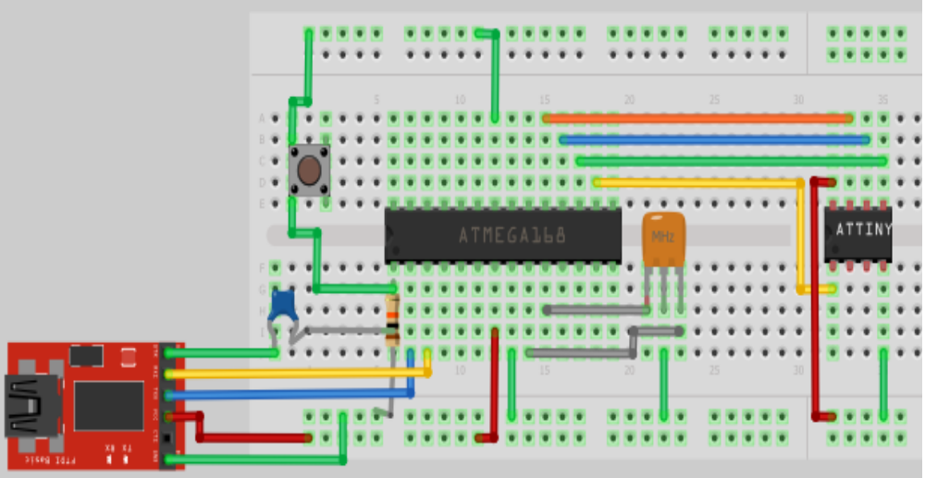

The Blink sketch with the TINY85
The blink sketch is pretty much the same as for the 328 except for the pin needs to be switched. I like to start with pin 0, so I open the blink sketch and change the pin 13 lines to pin 0.
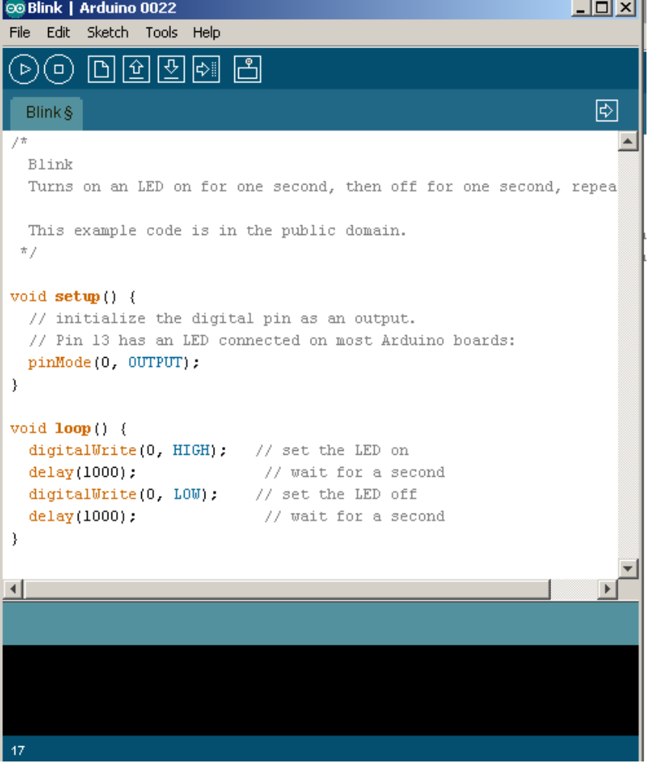

And Beyond
The At85 through the Arduino environment is a recent development, only a few of us have explored it at all. What's great is that this leaves a lot of open territory for you to find out the limits of this tool.

More on the Chips
Chip internals overview (328)
Follow data sheet for all discussion (show how students can find this out for themselves)
Processing core
Brief overview of ALU, memory / registers, execution pipeline
Instruction set (brief, because you don’t really need to know this)
What does the compiler do?
Run compiler on simple blink, look at resulting assembly code
The clock and how it drives everything
Reset
Interrupts
Programming (how does stuff get into flash?)
I/O ports
direction register, input register, output register
electrical states - high-Z, etc.
special functions, pullups, interrupts
Briefly describe peripheral blocks
Briefly describe how one uses a peripheral block (pick one as an example)
What does Arduino give you access to?
How to get access to things Arduino “hides”
Useful .h files (with register names, etc.)
Directly accessing ports and bit manipulation tricks
Brief overview of other chips and families, and where to find more information

