Thanks for attending Etiquette’s first LilyPad Arduino Workshop for Girls!

We’re so glad we could work with you today! We put this little take-home kit together so you can experiment on your own. Sew the coin cell battery/holder and LED together to make your clothes, backpack, or any material light up.

Materials Included:
1 Coin Cell Battery
1 Sewable Coin Cell Battery Holder
1 LED
Conductive Thread

Step 1: Draw a diagram of how the LED and battery holder will create a circuit using the conductive thread. It should look something like this. It’s good to have an idea of where everything’s going so you can sew everything right the first time. Testing out your projects with thread or alligator clips is always a good idea.

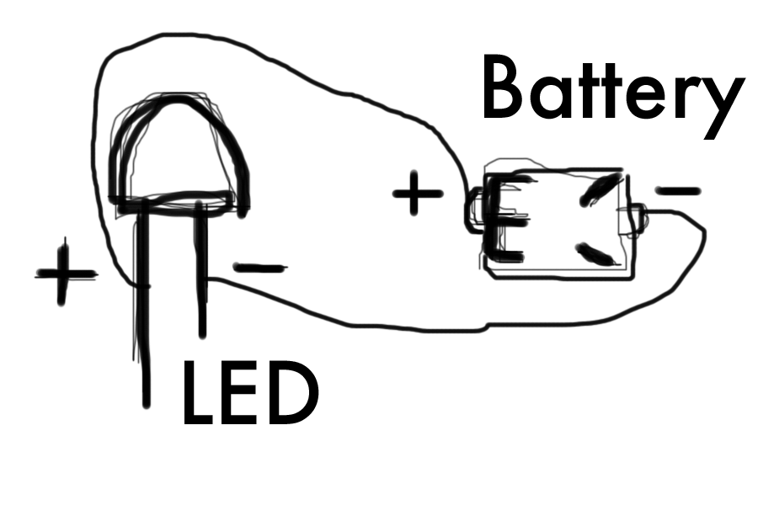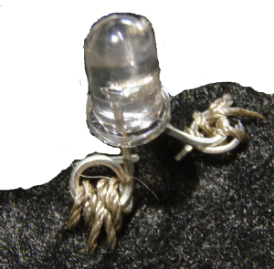
Step 2: You may need a parent’s help on this one. Use pliers to bend the LED wires into a circle and a square, above right (so you can tell the difference between the positive and negative). Be careful!

Step 3: Using the conductive thread and needle, connect the positive end of the sewable coin cell battery holder to the positive end of the LED by stitching the thread between them. It’s good to put a couple extra loops around the beginning and end of the connection. You’ll want to do the same for the negative sides too.

Step 4: Once everything is sewn together, the led should light up when you put the battery in. If something’s not working, look around and try again.

Helpful Tips:
Conductive thread can fray easily. To keep the ends of the thread in tact, put a small drop of hot glue on the ends of your connections

Other Resources (Ask for your parents permission before going online)
http://etiquettecreative.wordpress.com
http://www.instructables.com/
http://web.media.mit.edu/~leah/LilyPad/
http://www.sparkfun.com/
http://blog.craftzine.com/archive/2009/03/craft_video_lilypad_arduino_10.html

How was it today? LilyPad Arduino Activity

What was at least one good thing about the LilyPad Arduino activity?

What is something we could do better?

Are you more interested in learning more about the LilyPad Arduino?

What was your favorite part? and did you have a least favorite part?

Why?

